Evaluation Report

EMI Calculation Failed Despite Clear Inputs:
Issue Description
The system failed to compute the EMI even though the user provided all necessary inputs clearly:
- Principal Amount: 500,000
- Interest Rate: 8.5%
- Tenure: 5 years
Despite having sufficient data, the assistant returned a failure instead of calculating the EMI.

Before Fix:
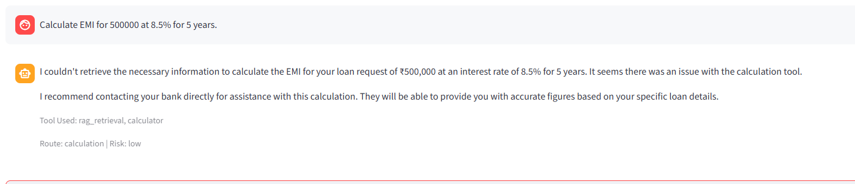

But the query already had all required values:

- Principal: 500000
- Interest rate: 8.5%
- Tenure: 5 years
So the assistant should not have failed.

Root Cause

Root Cause Analysis
The issue originated from how the query was processed:
- The planner correctly identified the query as a calculation task.
- However, the payload generation relied heavily on LLM-based extraction.
- The assistant failed to normalize and extract parameters reliably:
  - principal = 500000
  - annual_rate = 8.5
  - tenure_months = 60
- The calculator tool received malformed input:
  - annual_rate = "8.5%" (string with %)
- The tool could not interpret the percentage symbol, causing execution failure.

Fix
Solution Implemented
A deterministic EMI parser was introduced before the LLM fallback.
Key Improvements
- Direct extraction of structured values when all required inputs are present.
- Automatic normalization:
  - Converts tenure to months
  - Strips % from interest rates
- Eliminates dependency on LLM for critical numeric parsing.
Generated Payload (Post-Fix)
{
"operation": "emi",
"principal": 500000,
"annual_rate": 8.5,
"tenure_months": 60
}
Outcome
- EMI is now calculated reliably.
- The LLM is only responsible for explaining the result, not computing it.
- Significant improvement in accuracy and robustness.
The LLM explains the result, but does not calculate manually
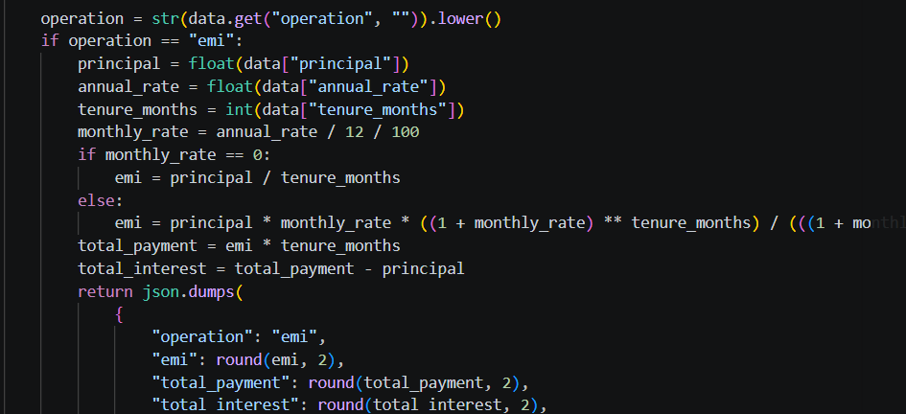

After Fix:

Post-Fix Behavior
- Queries with complete financial inputs are handled deterministically.
- No ambiguity in parameter extraction.
- Calculator tool consistently receives valid payloads.



Feedback Loop Failure:
Issue Description
The system collects user feedback and stores it in:
- Local memory: data/conversation_memory.jsonl
- Remote database: Supabase conversation_memory table
However, user preferences were not reflected in subsequent responses, indicating a failure in the feedback adaptation loop.

Before Fix:
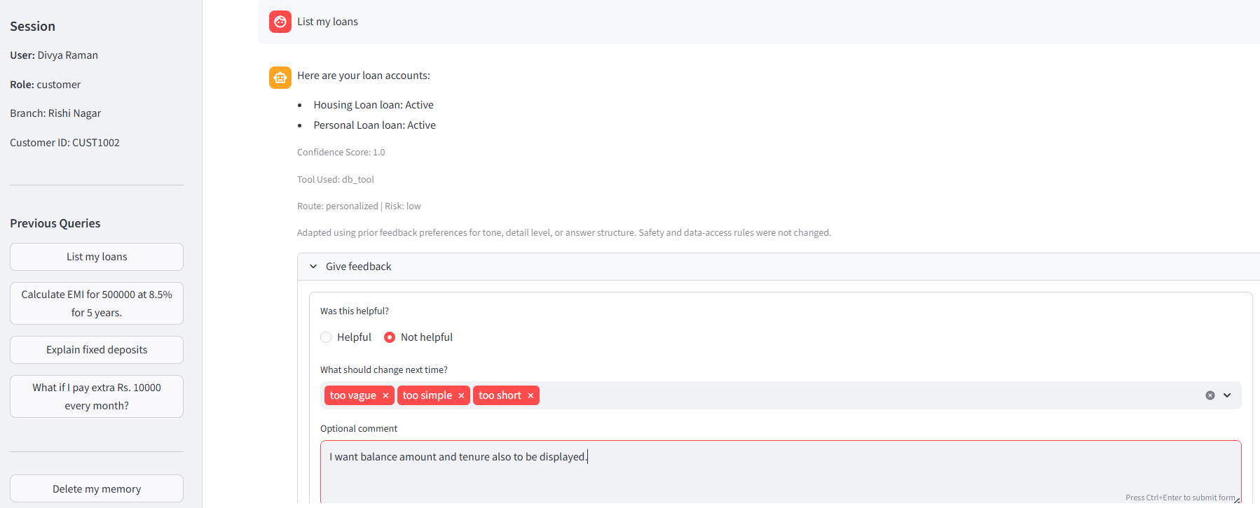

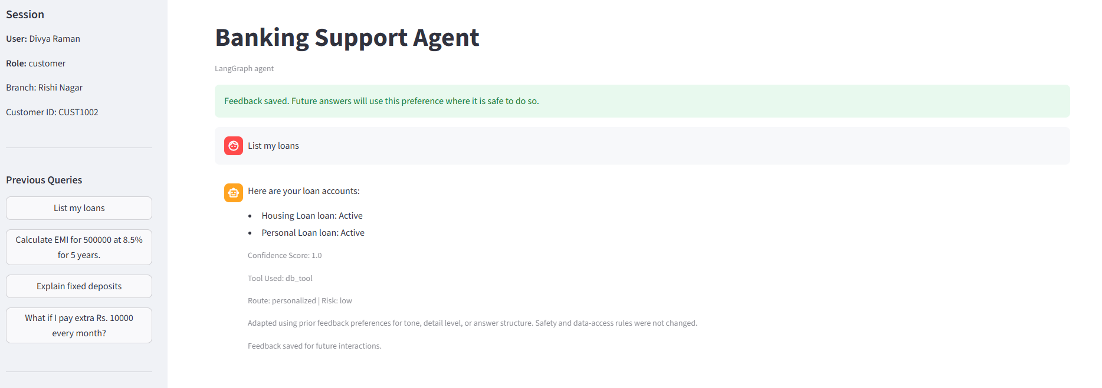

Coversation_memory.jsonl:
{"entry_type": "feedback", "user_id": "f657aceb23f974a3f0aba3530c4a6fd172418f5f5ee6083946ec3d65fc0530ee", "role": "customer", "query": "List my loans", "response": "Here are your loan accounts:\n- Housing Loan loan: Active\n- Personal Loan loan: Active", "route": "personalized", "risk_level": "low", "feedback_rating": "not_helpful", "feedback_tags": ["too vague", "too simple", "too short"], "feedback_comment": "I want balance amount and tenure also to be displayed.", "preference_summary": "Add more concrete details and next steps when sources support them. Provide a fuller explanation with useful context.", "last_active_at": "2026-04-30T08:35:24.020603+00:00", "created_at": "2026-04-30T08:35:24.020603+00:00"}
Problem:
- Feedback was successfully stored locally.
- But on re-running the query, the system did not adapt responses based on this feedback
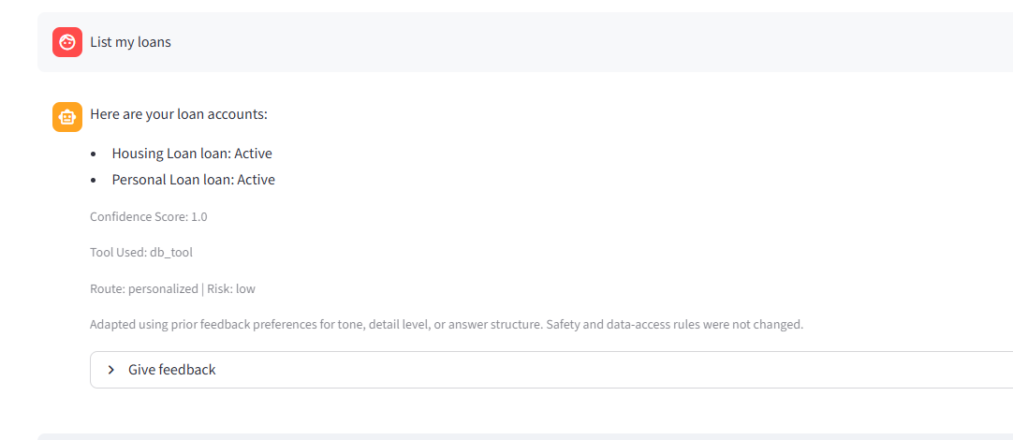

Root Cause:
Root Cause Analysis
- Feedback persistence to the Supabase database failed silently.
- The existing conversation_memory table schema was outdated and missing required columns:
  - entry_type
  - feedback_rating
  - feedback_tags
  - feedback_comment
  - preference_summary
- As a result:
  - Inserts partially failed or ignored new fields.
  - Preference retrieval returned incomplete data.

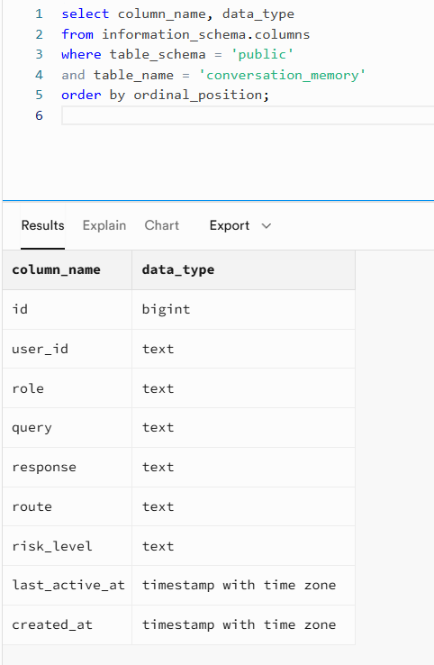

Fix:
The table schema was updated to include missing fields:
alter table public.conversation_memory
add column if not exists entry_type text default 'conversation';

alter table public.conversation_memory
add column if not exists feedback_rating text;

alter table public.conversation_memory
add column if not exists feedback_tags jsonb;

alter table public.conversation_memory
add column if not exists feedback_comment text;

alter table public.conversation_memory
add column if not exists preference_summary text;

update public.conversation_memory
set entry_type = 'conversation'
where entry_type is null;

After Fix:
• Feedback is now:
- Properly stored in the database
- Successfully retrieved during future interactions
• The system adapts responses based on:
- User preferences
- Feedback tags
- Contextual expectations

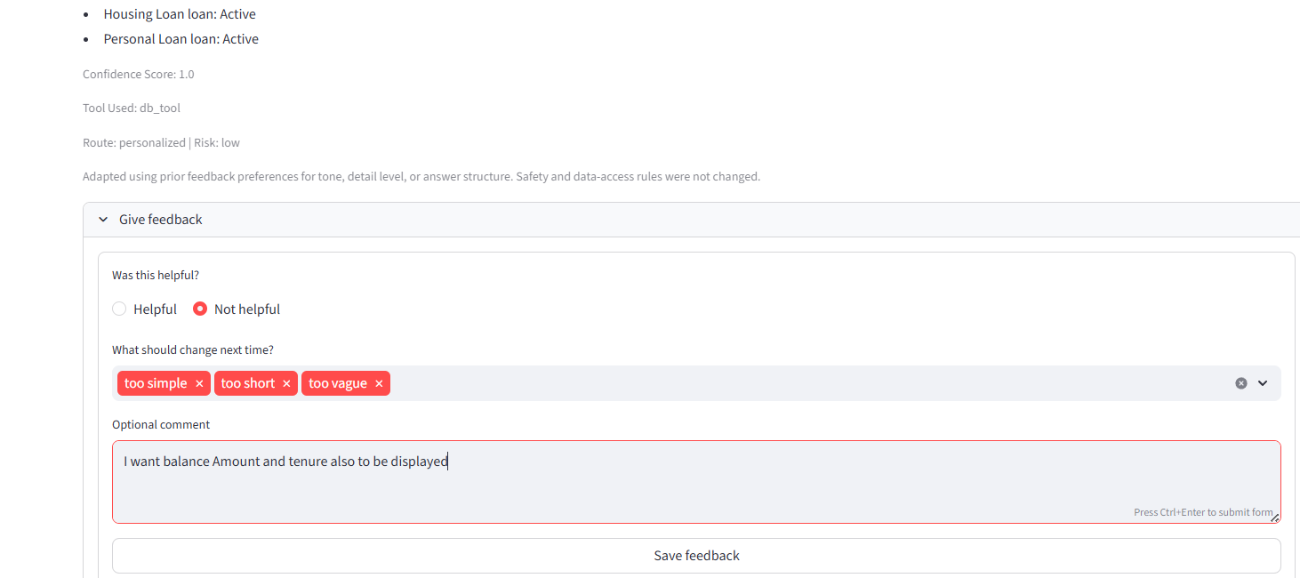
DB :
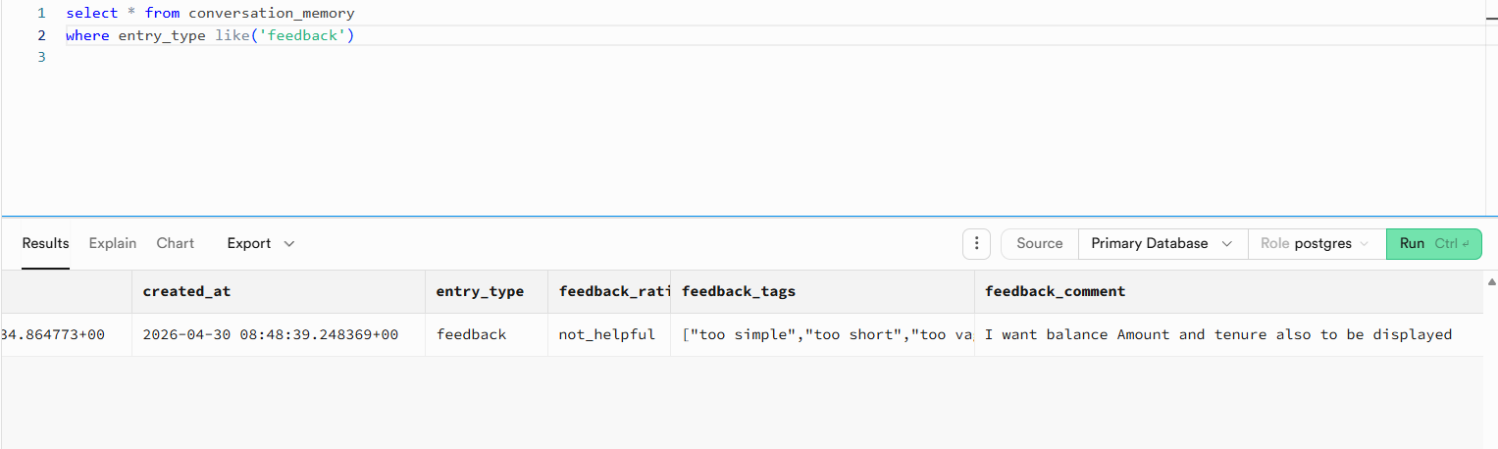
Customer Response :

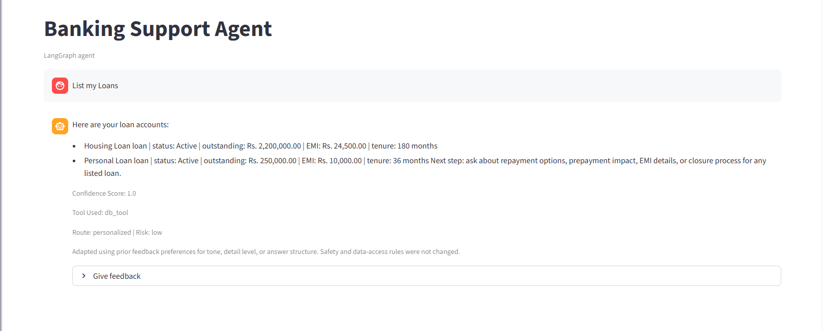
Improved System Behavior
- Responses are more detailed and aligned with user expectations.
- Example improvement:
  - Instead of just listing loans, responses now include:
    - Balance amount
    - Remaining tenure
    - Additional actionable insights

